ACT
The following 4 policies provide basic hospital cover and basic general treatment cover for 1 adult in ACT with no excess:
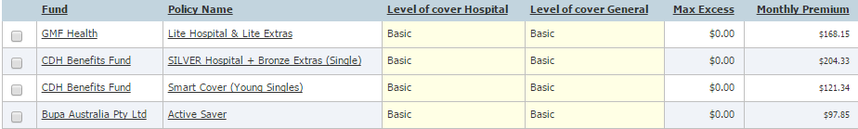

The following 9 policies provide medium hospital cover and medium general treatment cover for 1 adult in ACT with no excess:
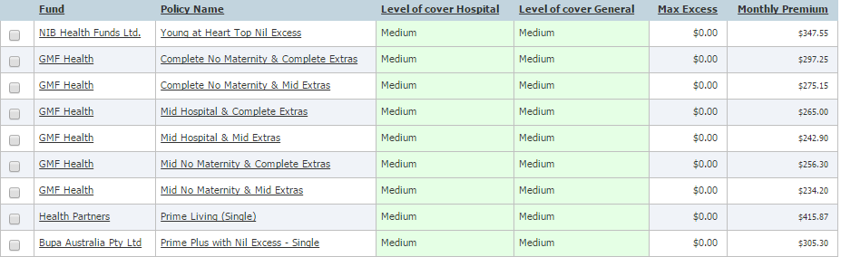

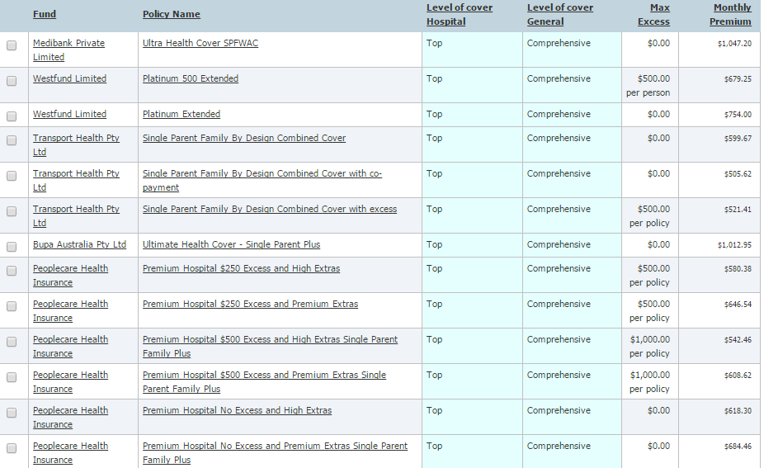
The following 13 policies provide top hospital cover and comprehensive general treatment cover for 1 adult with young adult dependants (includes children and students) in ACT:

The following 2 policies provide basic hospital cover and basic general treatment cover for 2 adults with children or students in ACT with no excess:
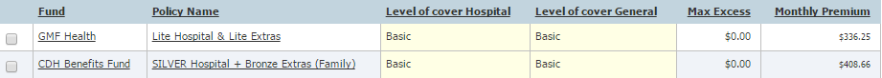

The following 6 policies provide medium hospital cover as well as a minimum of basic general treatment cover for 2 adults with young adult dependants (includes children and students) in ACT:
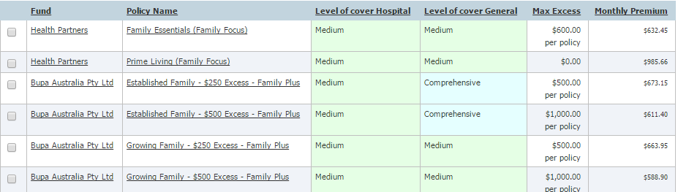

The following 14 policies provide top hospital cover and comprehensive general treatment cover for 2 adults with children or students in ACT with no excess or co-payments:
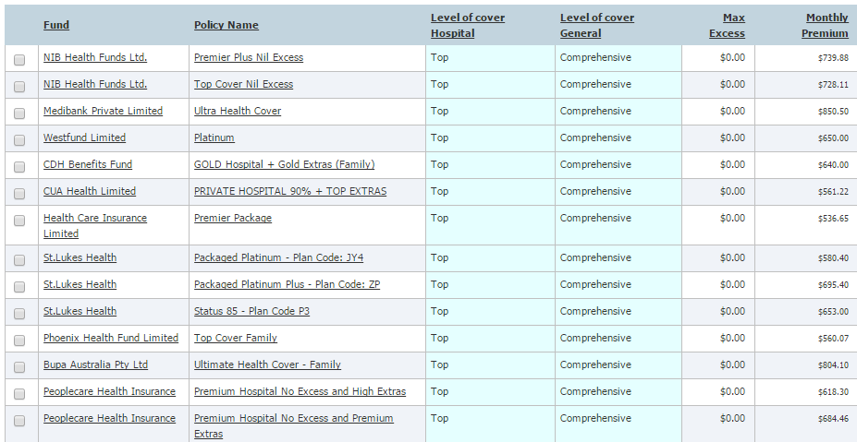

NSW
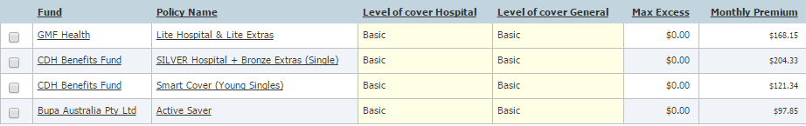
The following 4 policies provide basic hospital cover and basic general treatment cover for 1 adult in NSW with no excess:

The following 9 policies provide medium hospital cover and medium general treatment cover for 1 adult in NSW with no excess:
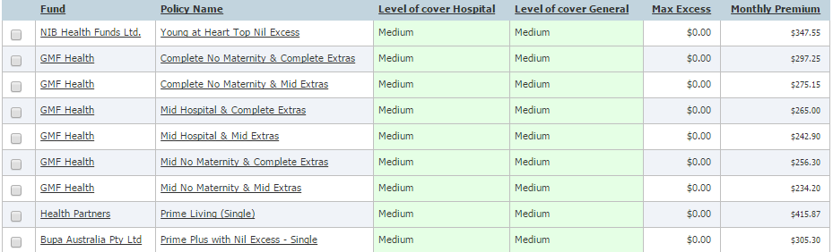

The following 13 policies provide top hospital cover and comprehensive general treatment cover for 1 adult with young adult dependants (includes children and students) in NSW:
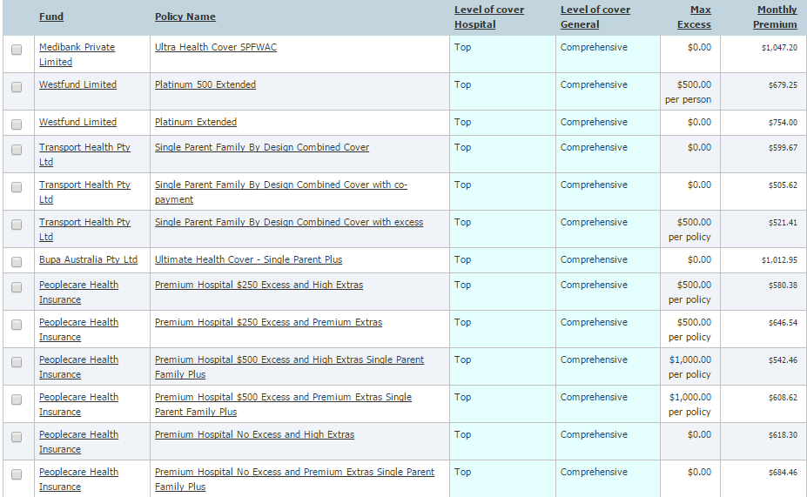

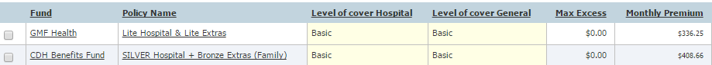
The following 2 policies provide basic hospital cover and basic general treatment cover for 2 adults with children or students in NSW with no excess:

The following 6 policies provide medium hospital cover as well as a minimum of basic general treatment cover for 2 adults with young adult dependants (includes children and students) in NSW:
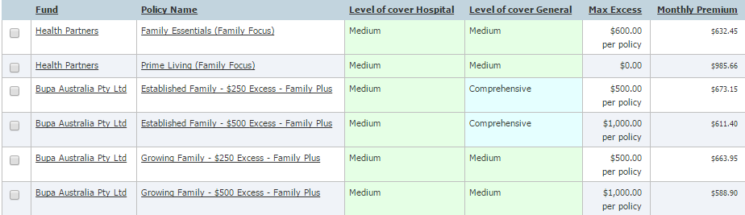

The following 14 policies provide top hospital cover and comprehensive general treatment cover for 2 adults with children or students in NSW with no excess:
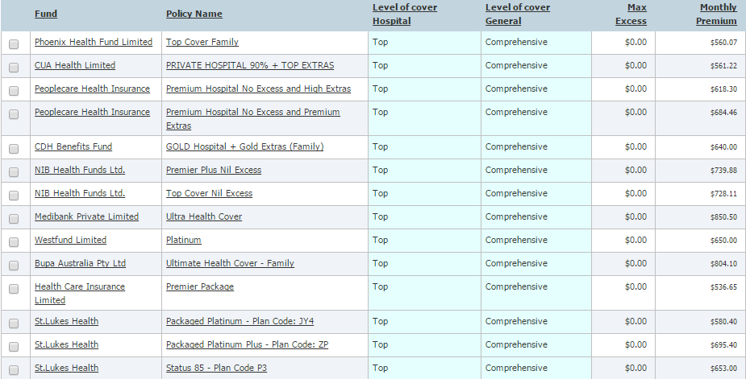

NT
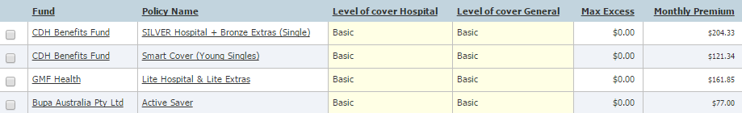
The following 4 policies provide basic hospital cover and basic general treatment cover for 1 adult in NT with no excess:

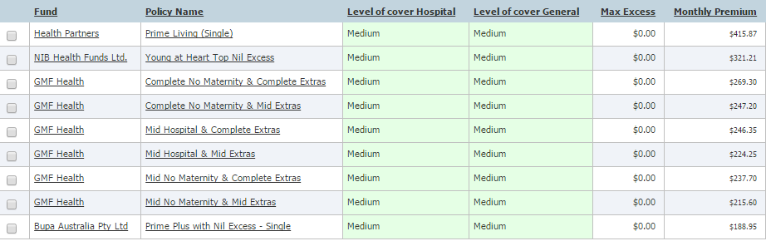
The following 9 policies provide medium hospital cover and medium general treatment cover for 1 adult in NT with no excess:

The following 16 policies provide top hospital cover and comprehensive general treatment cover for 1 adult with young adult dependants (includes children and students) in NT:
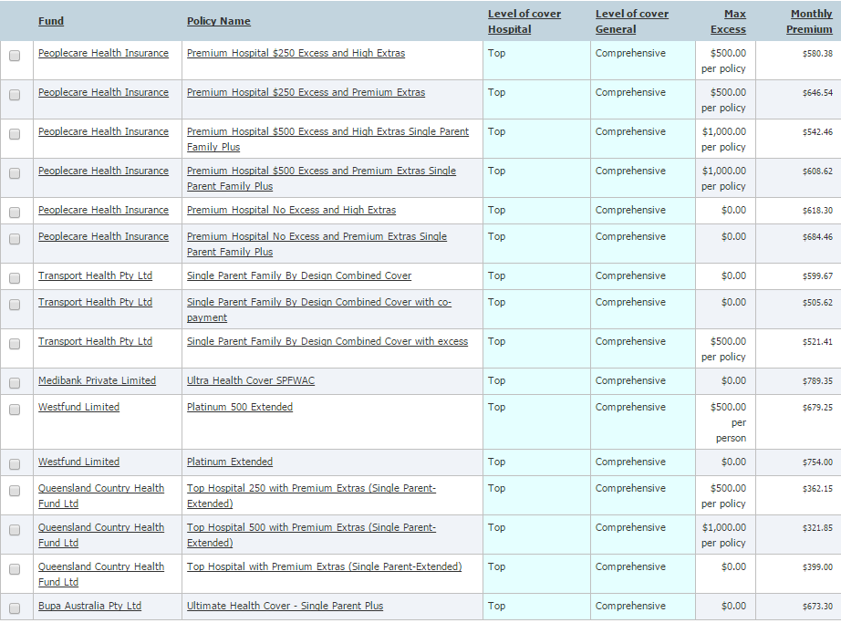

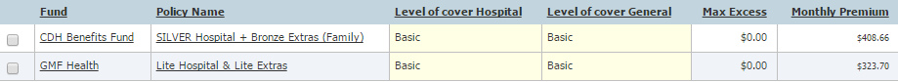
The following 2 policies provide basic hospital cover and basic general treatment cover for 2 adults with children or students in NT with no excess:

The following 6 policies provide medium hospital cover as well as a minimum of basic general treatment cover for 2 adults with young adult dependants (includes children and students) in NT:
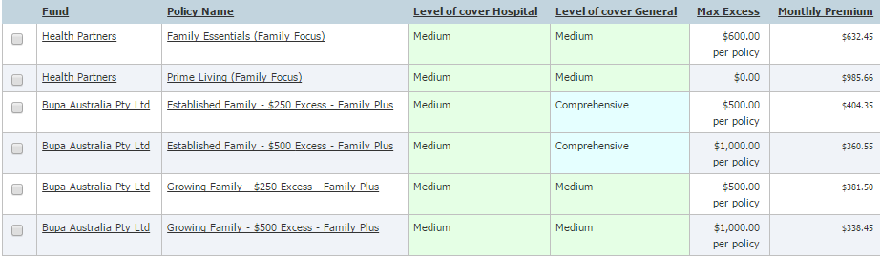

The following 15 policies provide top hospital cover and comprehensive general treatment cover for 2 adults with children or students in NT with no excess:
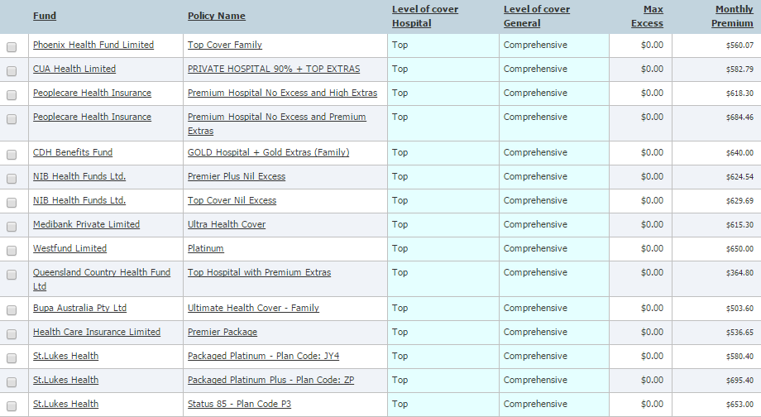

QLD
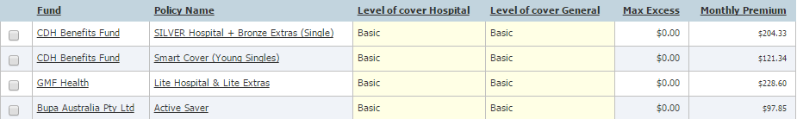
The following 4 policies provide basic hospital cover and basic general treatment cover for 1 adult in QLD with no excess:

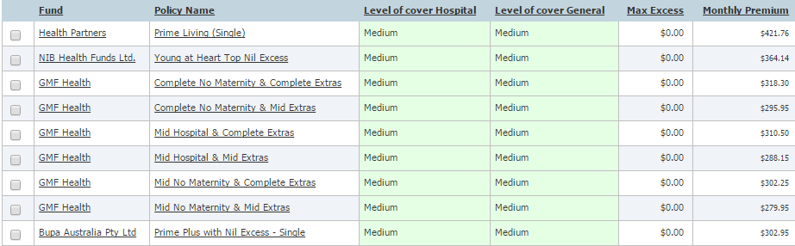
The following 9 policies provide medium hospital cover and medium general treatment cover for 1 adult in QLD with no excess:

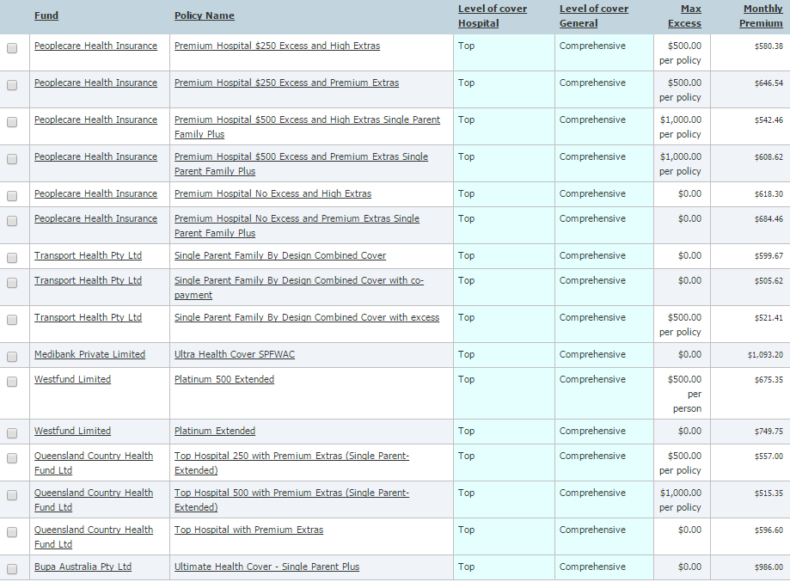
The following 16 policies provide top hospital cover and comprehensive general treatment cover for 1 adult with young adult dependants (includes children and students) in QLD:

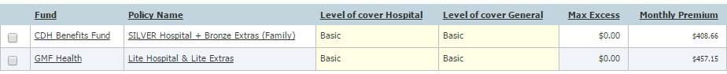
The following 2 policies provide basic hospital cover and basic general treatment cover for 2 adults with children or students in QLD with no excess:

The following 6 policies provide medium hospital cover as well as a minimum of basic general treatment cover for 2 adults with young adult dependants (includes children and students) in QLD:
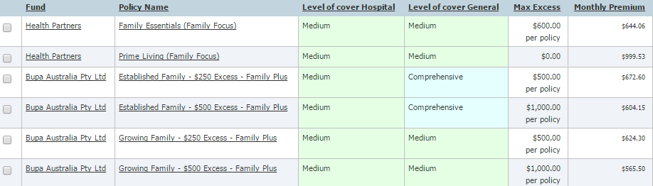

The following 15 policies provide top hospital cover and comprehensive general treatment cover for 2 adults with children or students in QLD with no excess:
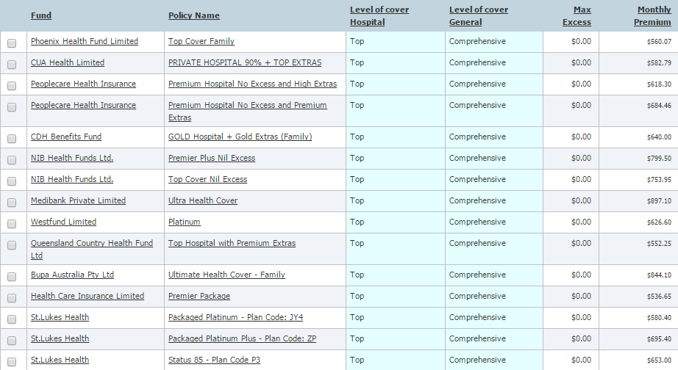

SA
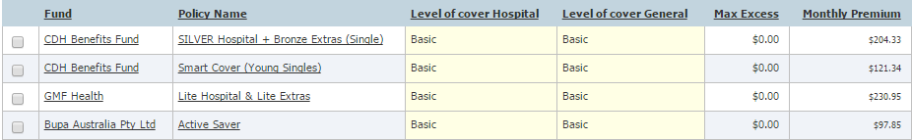
The following 4 policies provide basic hospital cover and basic general treatment cover for 1 adult in SA with no excess:

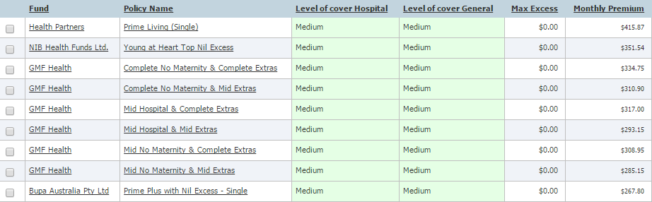
The following 9 policies provide medium hospital cover and medium general treatment cover for 1 adult in SA with no excess:

The following 13 policies provide top hospital cover and comprehensive general treatment cover for 1 adult with young adult dependants (includes children and students) in SA:
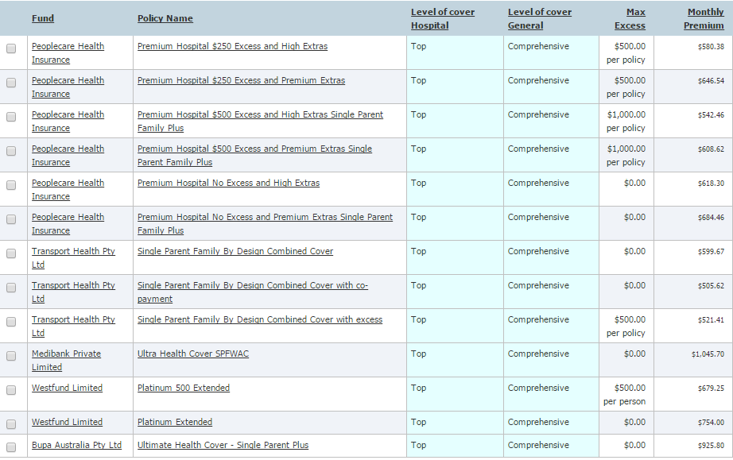

The following 2 policies provide basic hospital cover and basic general treatment cover for 2 adults with children or students in SA with no excess:
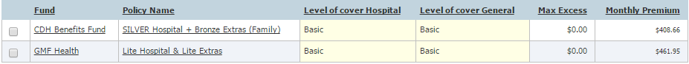

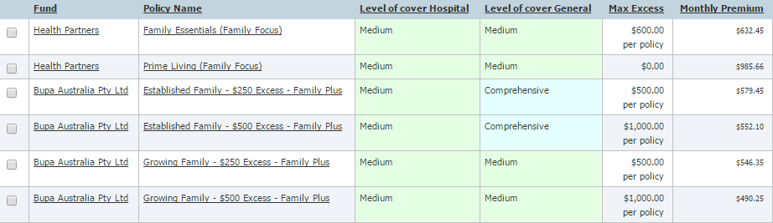
The following 6 policies provide medium hospital cover as well as a minimum of basic general treatment cover for 2 adults with young adult dependants (includes children and students) in SA:

The following 14 policies provide top hospital cover and comprehensive general treatment cover for 2 adults with children or students in SA with no excess:
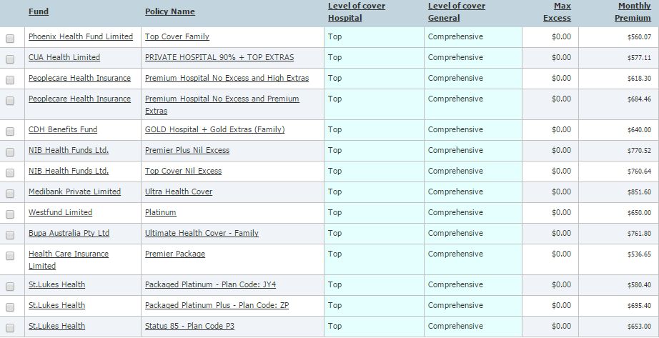

TAS
The following 4 policies provide basic hospital cover and basic general treatment cover for 1 adult in TAS with no excess:
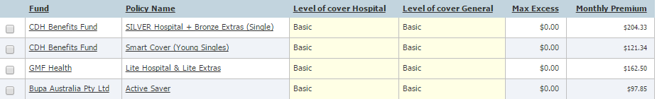

The following 9 policies provide medium hospital cover and medium general treatment cover for 1 adult in TAS with no excess:
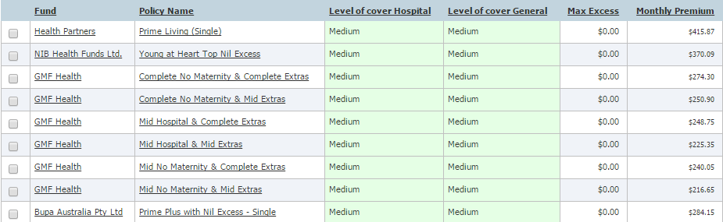

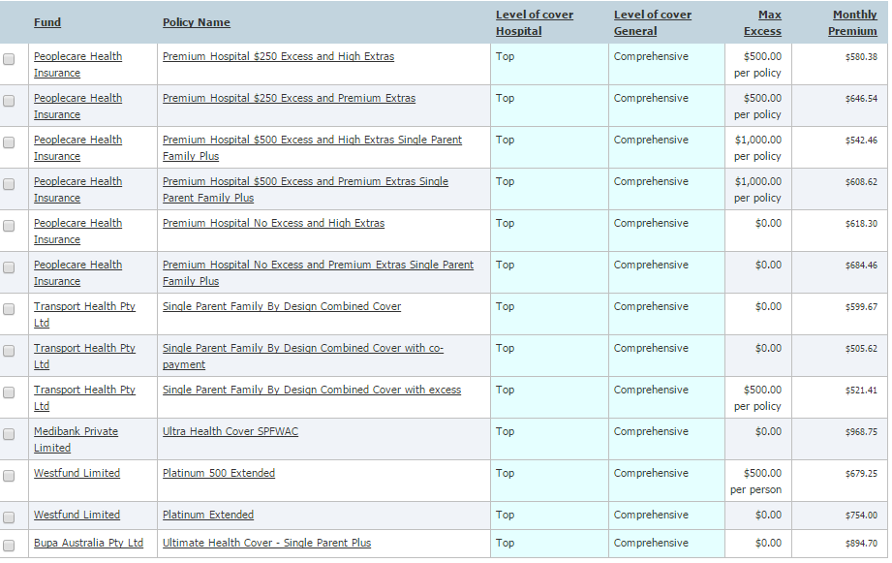
The following 13 policies provide top hospital cover and comprehensive general treatment cover for 1 adult with young adult dependants (includes children and students) in TAS:

\\

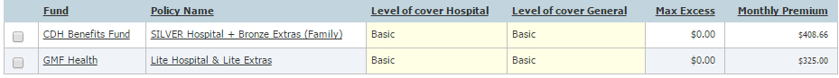
The following 2 policies provide basic hospital cover and basic general treatment cover for 2 adults with children or students in TAS with no excess:

The following 6 policies provide medium hospital cover as well as a minimum of basic general treatment cover for 2 adults with young adult dependants (includes children and students) in TAS:
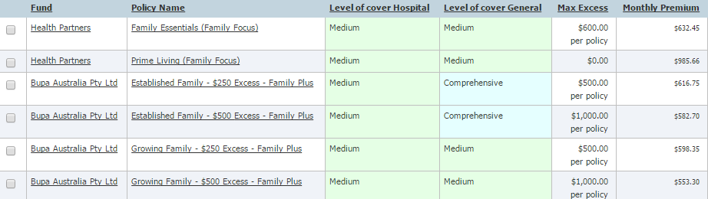

The following 14 policies provide top hospital cover and comprehensive general treatment cover for 2 adults with children or students in TAS with no excess:
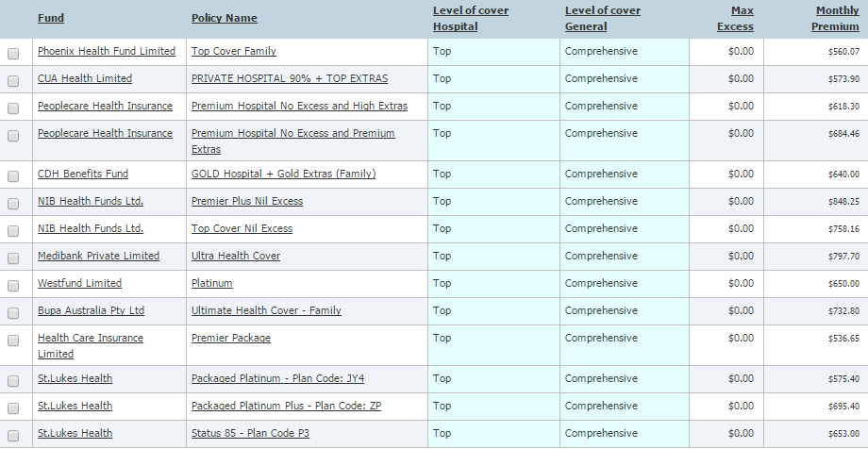

VIC
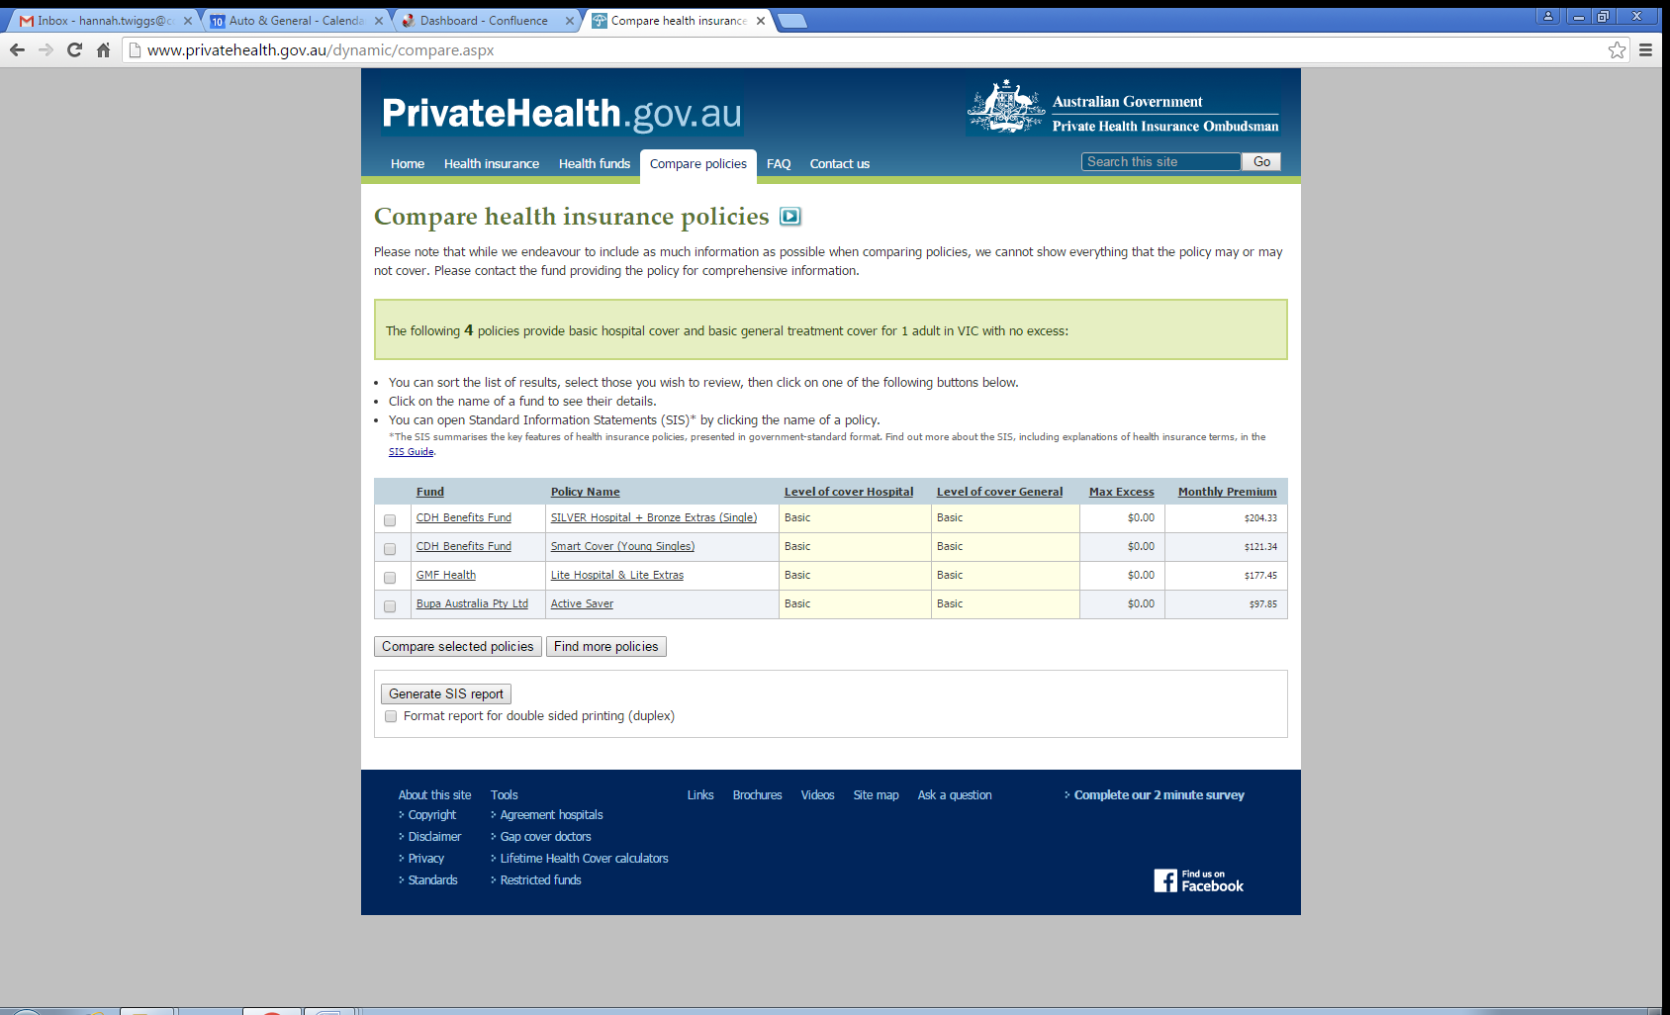
The following 4 policies provide basic hospital cover and basic general treatment cover for 1 adult in VIC with no excess:

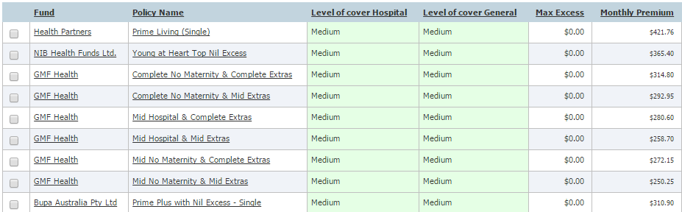
The following 9 policies provide medium hospital cover and medium general treatment cover for 1 adult in VIC with no excess:

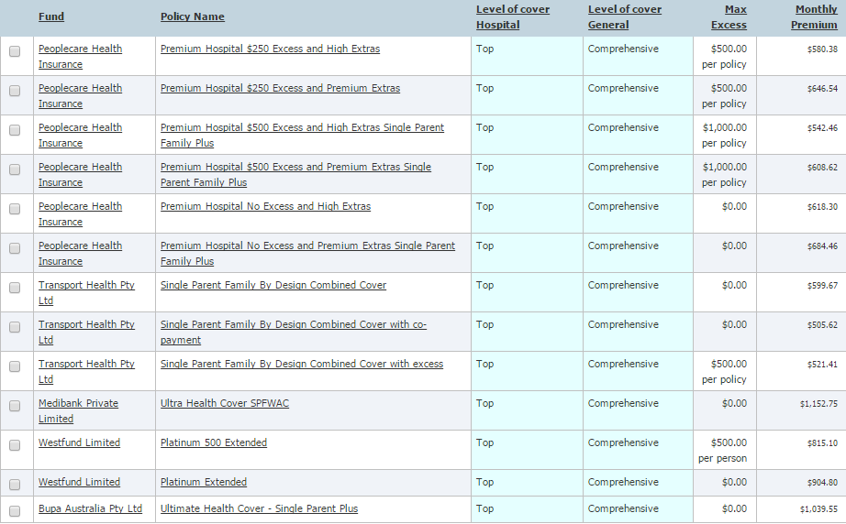
The following 13 policies provide top hospital cover and comprehensive general treatment cover for 1 adult with young adult dependants (includes children and students) in VIC:

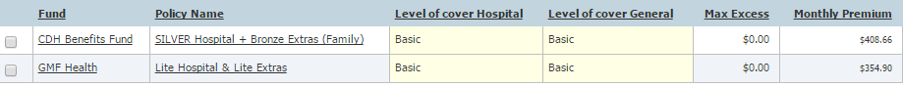
The following 2 policies provide basic hospital cover and basic general treatment cover for 2 adults with children or students in VIC with no excess:

The following 6 policies provide medium hospital cover as well as a minimum of basic general treatment cover for 2 adults with young adult dependants (includes children and students) in VIC:
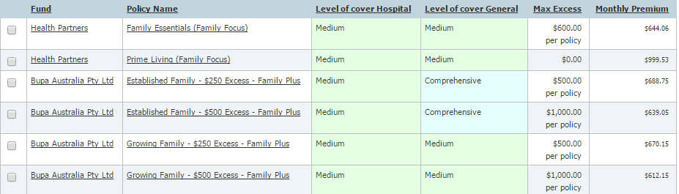

The following 14 policies provide top hospital cover and comprehensive general treatment cover for 2 adults with children or students in VIC with no excess:
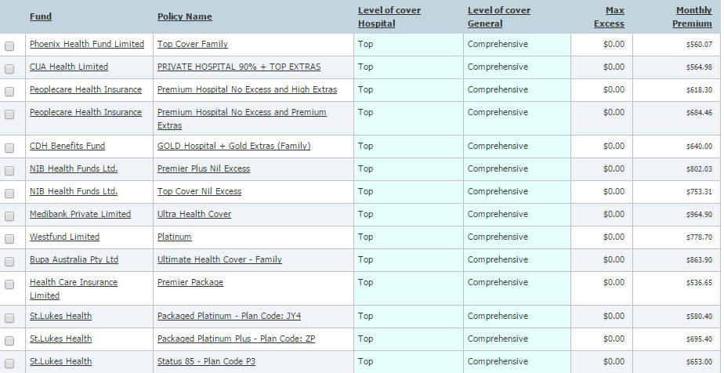

WA
The following 4 policies provide basic hospital cover and basic general treatment cover for 1 adult in WA with no excess:
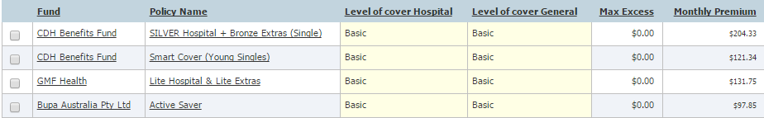

The following 9 policies provide medium hospital cover and medium general treatment cover for 1 adult in WA with no excess:
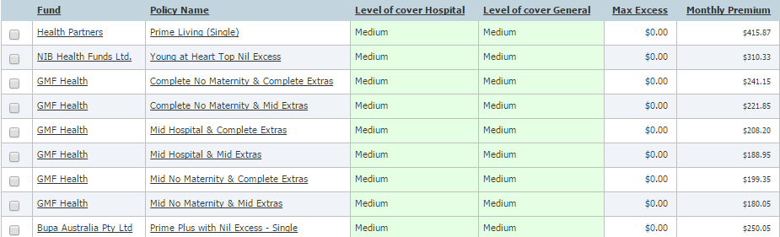

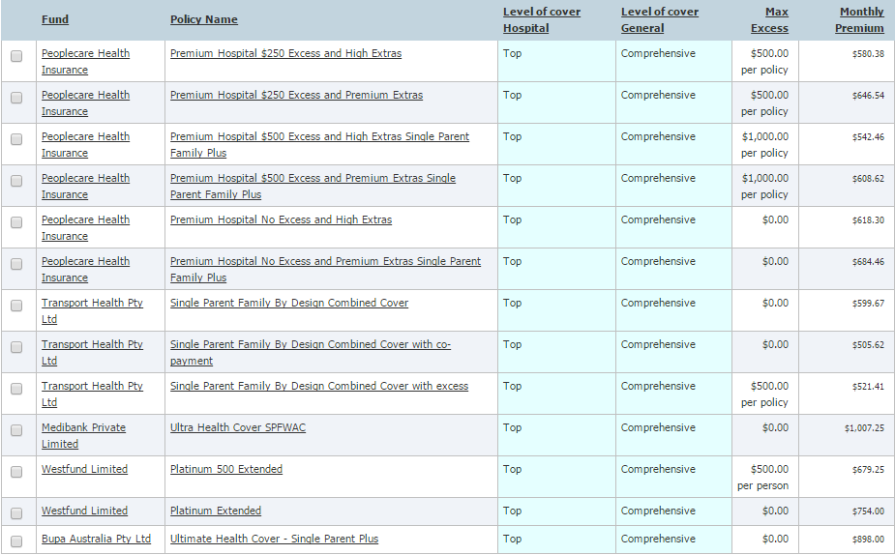
The following 13 policies provide top hospital cover and comprehensive general treatment cover for 1 adult with young adult dependants (includes children and students) in WA:

The following 2 policies provide basic hospital cover and basic general treatment cover for 2 adults with children or students in WA with no excess:
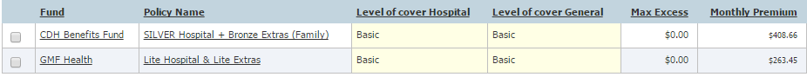

The following 6 policies provide medium hospital cover as well as a minimum of basic general treatment cover for 2 adults with young adult dependants (includes children and students) in WA:
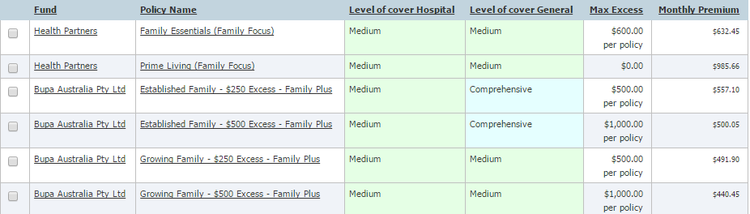

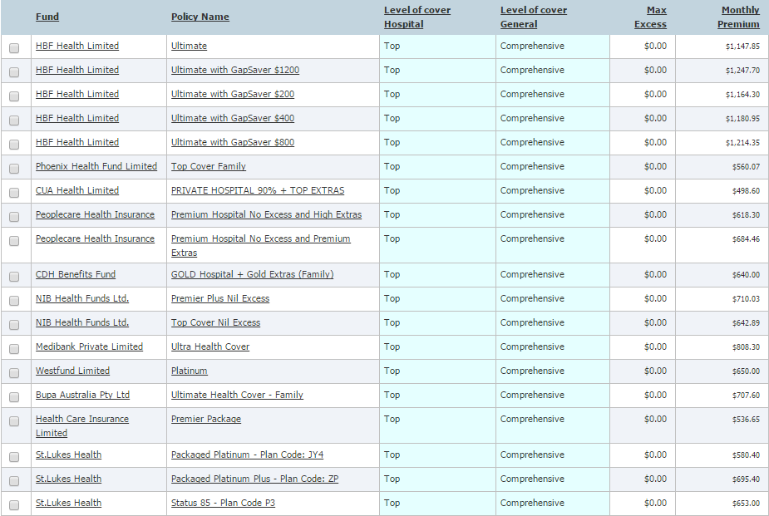
The following 19 policies provide top hospital cover and comprehensive general treatment cover for 2 adults with children or students in WA with no excess:

